SIMATS ENGINEERING
CO4 – AT1 - Article Review- Low
COURSE NAME: Advance Wireless Communication Systems / 5G / 6G Communication Systems
COURSE CODE: ECA5609
COURSE OUTCOME COVERED
CO: 5 - Develop 5G-enabled edge computing and IoT solutions for smart city, healthcare, industrial automation, and intelligent communication applications. (BL6)
Assessment Tool Weightage: 25%
Short description about assessment: Students review recent technical articles to assess critical thinking and awareness of trends.
Dr. K. Kalaiarasi
TITLE:
EDGE AI FOR INTELLIGENT 5G NETWORK OPTIMIZATION
ABSTRACT:
The rapid growth of 5G applications has increased the need for intelligent, low-latency, and efficient network management. Edge Artificial Intelligence (Edge AI) combines artificial intelligence with edge computing to process network data closer to its source, enabling faster decision-making without depending entirely on centralized cloud systems. This project focuses on using Edge AI for intelligent 5G network optimization by continuously monitoring parameters such as network traffic, bandwidth utilization, latency, signal quality, and resource availability. Machine learning techniques can analyze these parameters and predict network conditions, allowing resources such as spectrum, computing capacity, and network slices to be dynamically allocated. AI-based optimization can also support load balancing, congestion prediction, energy-efficient operation, and improved Quality of Service (QoS).
Recent research highlights the importance of distributed AI and closed-loop optimization across the RAN, edge, and core for evolving 5G networks.
By performing intelligence closer to users, the proposed approach aims to reduce response time, improve resource utilization, enhance network reliability, and provide adaptive services for demanding 5G applications such as IoT, autonomous systems, smart cities, and industrial automation.

NEW TECHNIQUES USED:
- Edge AI: Processes data near the network edge for faster decision-making and reduced latency.
- Machine Learning (ML): Predicts traffic patterns, congestion, and network performance.
- AI-Based Resource Allocation: Dynamically allocates bandwidth, spectrum, and computing resources.
- Intelligent Network Slicing: Creates and manages virtual network slices according to application requirements.
- Real-Time Traffic Prediction: Detects changing network traffic and predicts future load.
- AI-Based Load Balancing: Distributes network traffic efficiently among available resources.
- Energy-Efficient Optimization: Reduces unnecessary energy consumption by intelligently managing network resources.
- Federated Learning: Enables AI models to learn from distributed edge devices without sending all raw data to a central server.
- Predictive Network Management: Identifies potential congestion or performance issues before they occur.
- Closed-Loop Automation: Continuously monitors the network, makes AI-based decisions, and automatically adjusts network parameters.

CONCLUSION:
Edge AI provides an effective approach for making 5G networks more intelligent, adaptive, and efficient. By processing network data closer to the user, it reduces latency and enables faster decisions compared with centralized cloud-based processing. AI and machine learning techniques can be used to predict traffic, optimize resource allocation, balance network loads, improve Quality of Service (QoS), and reduce energy consumption. The integration of Edge AI with 5G can therefore support demanding applications such as IoT, smart cities, autonomous systems, and industrial automation. Overall, Edge AI-based network optimization improves network performance and provides a scalable foundation for future intelligent 5G and 6G communication systems.

BASE PAPER based on Edge AI on 5G Optimization:

SPECIAL ISSUE ON SELECTED PAPERS OF THE IEEE CONFERENCE ON STANDARDS FOR COMMUNICATIONS AND NETWORKING (CSCN)

On the Deployment of AI-Driven Solutions in Edge-Enabled Beyond 5G Scenarios

Jordi Pérez-Romero , Ömer Faruk Tuna , Oluwatayo Kolawole , Oriol Sallent , Irene Vilà , Nikolaos Bartzoudis , Elli Kartsakli , Joan S. Pujol Roig , Maria A. Serrano , and Utku Gülen

ABSTRAcT
The evolution beyond the Fifth Genera-tion (5G) of mobile communications systems is expected to exploit different advanced radio access techniques, such as distributed multiple input multiple output (D-MIMO) or network slicing, together with an extensive support of Artificial Intelligence (AI) and Machine Learning (ML) solutions for different aspects of network optimization. These systems will also benefit
important role to enhance the user experience across the coverage area [2].
Fostered by the growing capabilities of com-munication infrastructures, emerging applications such as extended reality involving computationally heavy functions, such as rendering or spatial com-putation [3], are expected to progressively enter the mobile ecosystem. Nevertheless, the limita-tions of end user devices require offloading heavy tasks to more powerful computing elements.
As such, edge computing has arisen as a novel

from the evolution of edge computing technol-ogies through the availability of computing and storage capabilities that will span from the radio access network nodes to the cloud, forming an edge-to-cloud compute continuum. The avail-ability of these features will provide the beyond 5G (B5G) and 6G networks with an increased flexibility for deploying the different AI/ML-based optimization functionalities, trading-off aspects such as delay requirements, computational com-plexity or availability of data for feeding the AI/ ML models. In this context, this paper takes as a reference the evolved edge computing architec-ture of the VERGE project and presents a pipeline with the required functionalities for the lifecycle management of AI/ML models in edge-enabled B5G systems. This pipeline is particularized for the deployment of two specific AI-driven solutions used for capacity sharing in network slicing and for D-MIMO power control.

INTRODUcTION
The evolution of communication networks beyond 5G (B5G) and towards 6G is expected to deal with the diverse and challenging require-ments of innovative, immersive, and real-time vertical services [1]. Emerging architectural designs featuring network function virtualization and Radio Access Network (RAN) disaggregation offer enhanced flexibility and scalability. Similarly, Artificial Intelligence (AI) and Machine Learn-ing (ML)-enabled solutions leverage monitoring data to optimize both network and application performance, achieving zero-touch closed-loop automation. Moreover, advanced radio access techniques, such as distributed multiple input mul-tiple output (D-MIMO), are expected to play an
paradigm that brings computational power and resources closer to where the data is generated, thus considerably reducing response times [4].
The synergy between B5G and edge com-puting can provide computing and storage capabilities for applications residing at the boundary of operators’ networks. This can be par-ticularly relevant for functionalities with varying communication, computing and data consump-tion demands, such as the lifecycle management (LCM) processes of AI/ML-based solutions (e.g., training, inference), suggesting that they can be hosted at different points of the network. For example, an offline training that requires massive amounts of data and computations to build an accurate AI/ML model can run on a central cloud. In contrast, an inference stage that uses a previ-ously trained model mostly requires a fast reaction time to quickly adapt to network variations, so it is more appropriately hosted on an edge server.
In this context, this paper considers a B5G
scenario built upon the following components:
(1) a disaggregated RAN with advanced features such as slicing and D-MIMO, (2) an edge-to-cloud compute continuum with a heterogeneous pool of connected edge and cloud resources,
(3) extensive support of AI/ML-based techniques for the automated management of network and compute resources. To support this B5G scenario, this paper takes as a reference the system archi-tecture of the VERGE project [5] and addresses the deployment of AI/ML solutions on top of this architecture.
Specifically, the contributions and novelties of this paper are summarized as follows. First, the paper presents a pipeline with the pro-cesses needed for the LCM of trustworthy AI/
This work was supported in part by the VERGE Project from the Smart Networks and Services Joint Undertaking (SNS JU) through the Europe-an Union’s Horizon Europe Research and Innovation Programme under Grant 101096034; and in part by the Samsung Research U.K. participants in Horizon Europe Project VERGE through UKRI under Grant 10071211. The work of Ömer Faruk Tuna and Utku Gülen was supported
in part by the Scientific and
Technological Research Council of Turkey (TUBITAK) through the 1515 Frontier Research and Development Laboratories Support Program under Project 5169902. The work of Jordi Pérez-Romero, Oriol Sallent, and Irene Vilà was supported by the TRAIN-ER-6G Project through MCIN/ AEI/10.13039/501100011033
and ERDF/EU under Grant
PID2023-146748OBI00.
The work of Nikolaos Bartzoudis was support-ed in part by MICIU/
AEI/10.13039/501100011033
and the European Union NextGenerationEU/PRTR under Project PID2023-146245OB-C22. The
work of Elli Kartsakli was supported in part by the PROXIMITY Project through AEI/10.13039/501100011
033/FEDER, UE, under Grant PID2021-124122OA-I00.

Digital Object Identifier:

Jordi Pérez-Romero (corresponding author), Oriol Sallent, and Irene Vilà are with the Universitat Politècnica de Catalunya (UPC), 08034 Barcelona, Spain; Ömer Faruk Tuna and Utku Gülen are with Ericsson Research, 34467 Istanbul, Türkiye (e-mail: jordi.perez-romero@upc.edu); Oluwatayo Kolawole and Joan S. Pujol Roig are with the Samsung Research and Development Institute, TW18 4QE Staines, U.K.; Nikolaos Bartzoudis is with the Centre Tecnològic de Telecomunicacions de Catalunya (CTTC/CERCA), 08860 Barcelona, Spain; Elli Kartsakli is with the Barcelona Supercomputing Center, 08034 Barcelona, Spain; Maria A. Serrano is with Nearby Computing, 08006 Barcelona, Spain.
10.1109/MCOMSTD.2025.3640682
Date of Current Version:
22 May 2026
Date of Publication: 29 December 2025

© 2025 The Authors. This work is licensed under a Creative Commons Attribution 4.0

5G, 6G | Fifth Generation, Sixth Generation
AI | Artificial Intelligence
B5G | Beyond 5G
CU | Central Unit
dApp | distributed application
D-MIMO | Distributed Multiple Input Multiple Output
DNN | Deep Neural Network
DQN | Deep Q Network
DU | Distributed Unit
LCM | Lifecycle management
MARL | Multi-Agent Reinforcement Learning
ML | Machine Learning
NDT | Network Digital Twin
OMC | Orchestration, Management and Control
RAN | Radio Access Network
RIC | RAN Intelligent Controller
RL | Reinforcement Learning
RU | Radio Unit
SPT4AI | Security, Privacy and Trustworthiness for AI
UE | User Equipment
UPF | User Plane Function
TABLE 1. Glossary.

ML models for edge-enabled B5G systems. Then, the paper analyses the deployment of this pipeline on top of the edge-to-cloud com-pute continuum of a B5G network for two AI/ ML solutions, namely a capacity sharing approach for RAN slicing and a D-MIMO power control strategy. The analysis addresses aspects such as the adequate placement of the LCM functions or the acquisition of the required data. This analysis substantially extends the initial work [6] that stud-ied the D-MIMO power control strategy. Finally, the paper discusses the practical implementation aspects of the two solutions in relation to the O-RAN alliance specifications.
The paper is organized as follows. First, the edge-enabled B5G architecture of the VERGE project is described. Then, the AI/ML LCM pipe-line is presented and particularized for the two AI-driven solutions. Afterwards, the relationship with O-RAN is discussed and conclusions are summarized. Table 1 includes the acronyms used in the paper.

HIgH-LeveL ARcHITecTURAL OveRvIew
Edge computing involves an ecosystem of highly heterogeneous computing elements, spanning from embedded devices, intelligent base sta-tions and edge servers, to home gateways and micro-datacenters [7]. These can be located prac-tically anywhere across the path between the
end-devices and the access and core networks. Along with the central cloud, they compose a compute fabric denoted as edge-to-cloud com-pute continuum. Virtualized services can be flexibly deployed and executed there based on their requirements and available infrastructure.
In this context, VERGE project proposes an evolved edge computing architecture integrated with the B5G network. It enables the seamless execution of cloud-native services, including disaggregated RAN functions, core network functions, AI-powered applications, and AI-based edge and network optimization functions. The VERGE architecture is modular and scalable, facilitating the levels of overall trustworthiness needed by the AI-based solutions that are used to adapt the platform to the diverse and ultra-de-manding requirements of 6G applications.
A high-level overview of the architecture is shown in Fig. 1, where the edge-to-cloud com-pute continuum infrastructure is depicted at the bottom. This abstracts all the available compute resources where the different applications, ser-vices, and intelligent algorithms are executed and orchestrated. The 5G/6G network components including RAN, core, and transport network are represented under this infrastructure. The figure also depicts the functionalities associated to the three VERGE pillars and their interactions.
The first pillar is the “edge for AI” (Edge4AI), which is a flexible, modular and converged edge platform design that unifies the LCM and closed-loop automation for cloud-native applications and network services across the edge-to-cloud compute continuum. It is based on three key components, namely the Orchestration, Man-agement, and Control (OMC) layer that provides the control functionalities to optimize the system operation, the cognitive framework that enables the LCM of AI/ML models, and a set of pro-gramming models used for the development or optimization of services. The second pillar is the “AI for edge” (AI4Edge), which includes a portfolio of AI-based solutions to manage and orchestrate the computing and network resources. The third pillar is the “security, privacy and trustworthi-ness for AI” (SPT4AI), which provides a suite of methods and tools to ensure the security of the AI-based models against adversarial attacks, the privacy of data and models, the explainability of AI-driven decision making and the safe training and execution of such models. Further details on the VERGE architecture are available in [5].
Multiple stakeholders are involved in this com-
plex ecosystem, including telecom operators, edge and cloud infrastructure providers, equipment manufacturers, and end users (e.g., vertical indus-tries). All these stakeholders will benefit from this modular design, although their interactions and relevant business models extend beyond the pro-posed architecture. A notable group among these stakeholders are the software developers, which design the applications, networks, and AI-en-abled services that run on this heterogeneous infrastructure. As shown in Fig. 1 application and network function developers design the vertical applications and virtualized network functions to be deployed on the compute continuum infra-structure. Potentially they leverage the Edge4AI programming models and frameworks for higher

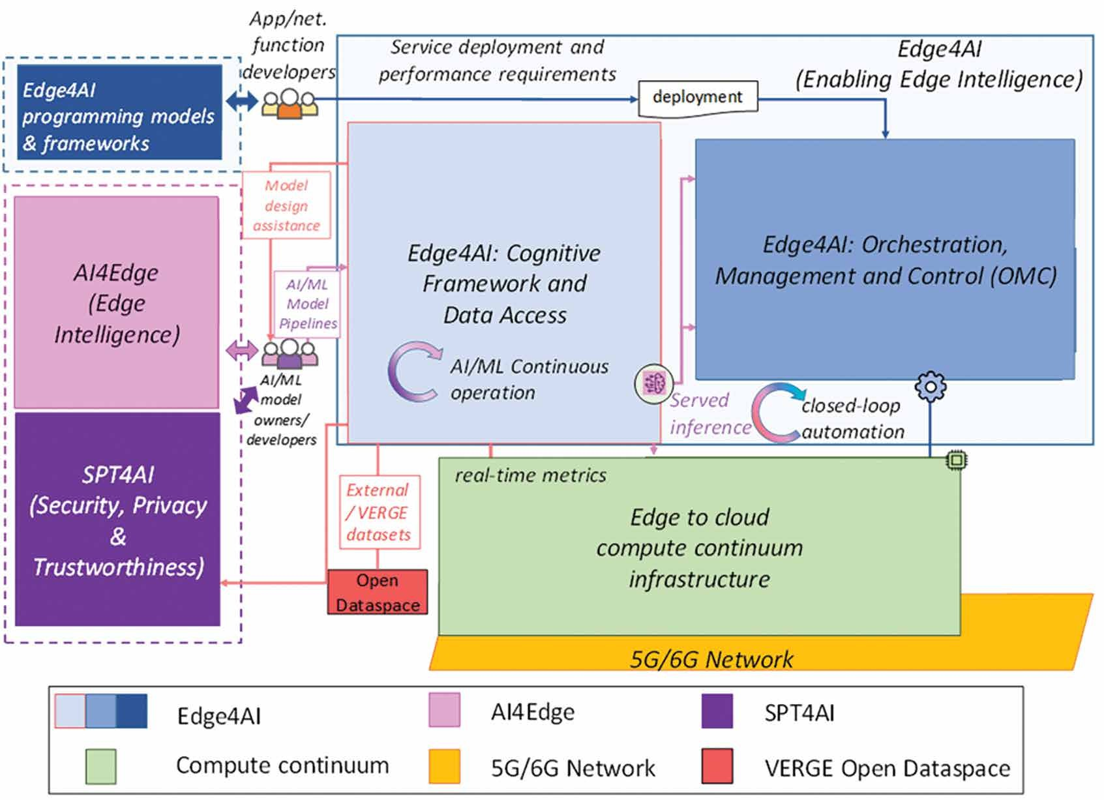
FIGURE 1. High level overview of the VERGE architecture.

programmability and abstraction. Furthermore, AI/ML model developers design intelligent solu-tions for automation and optimization, accessing the portfolio of AI/ML models and services within the AI4Edge and SPT4AI pillars through the cognitive framework. Finally, the results of the inference of the AI/ML models are consumed by the components of the OMC layer, providing the necessary insights for intelligent decision-making, closing the loop of the management and orches-tration plane.
LIfecycLe MANAgeMeNT Of AI/ML PROceSSeS
The LCM of an AI/ML model defines a struc-tured process with the stages needed for the development, deployment, monitoring and main-tenance of the model. This targets that the model is built on high quality data, properly validated and achieves the expected performance when it is deployed. Fig. 2 presents the LCM pipeline considered by the VERGE project to ensure an efficient, secure and trustworthy operation of AI/ML models. It encompasses several intercon-nected stages that handle data ingestion, model training and validation, model deployment, infer-ence serving and monitoring. It is also designed to include continuous feedback loops enabling ongoing improvement and adaptation of AI/ML models.
The implementation of this pipeline is enabled
by the cognitive framework, which integrates all the different processes and provides the inter-faces for the data ingestion and the inference serving endpoints. To that end, the cognitive framework offers ML operations supported by the AI4Edge and the SPT4AI functionalities. AI4Edge provides the core AI/ML capabilities, including
various learning approaches (e.g., supervised, unsupervised, reinforcement learning (RL)) and application-specific models (e.g., for resource orchestration, network optimization). In turn, SPT4AI integrates security, privacy, and trustwor-thiness measures throughout the AI/ML lifecycle. Examples of SPT4AI functionalities include pro-tection of models against adversarial attacks, privacy-enhanced federated learning, trustworthy RL, formal verification, causal AI and explainable AI [5]. The implementation details of the VERGE cognitive framework including the used software tools are presented in [8] (sections 6 and 13).
The next two subsections describe in more detail the AI/ML lifecycle stages, divided in two main phases: (1) model training and deployment, and (2) model inference and monitoring. After-wards, two examples of applicability of the LCM pipeline for two RAN optimization models will be described.

MODeL TRAININg AND DePLOyMeNT PHASe
The first stage of this phase is the Data Ingestion, which starts with the data extraction, where raw data is collected from various sources including network elements, sensors, user devices, etc. This is done through the Data Access Layer, which provides real-time data flows from the infrastruc-ture (e.g., RAN elements, edge devices). In a B5G network data could come from cell performance measurements and counters. Following extraction, data validation ensures the quality of incoming data. This step involves checking for completeness, consistency, and accuracy, as well as identifying anomalies or outliers that could impact model training (e.g., values of counters erroneously set to zero or not collected in a measurement period).

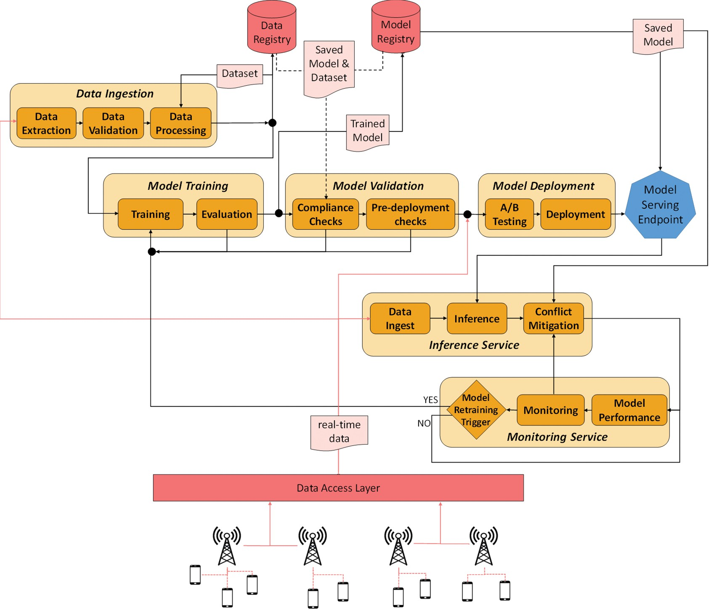
FIGURE 2. Overview of the AI/ML LCM pipeline

It also implements data governance policies to comply with privacy regulations and data handling standards [9]. The validated data then under-goes data processing. This involves cleaning and normalizing data to ensure consistency across dif-ferent sources, creating relevant input features for AI/ML models, and performing data augmenta-tion when necessary to address class imbalances or enhance model robustness. The processed data, together with pre-processing parameters and used filters, is stored in the data registry for effec-tive tracking and data management. This facilitates data consistency and reproducibility across the different stages.
The Model Training stage leverages the pro-cessed data for training, utilizing AI4Edge components to implement various ML paradigms, such as RL or federated learning. For example, if the AI/ML model uses a neural network, the training will adjust the weights of the neurons to obtain adequate outputs. AI4Edge solutions use the AI/ML development toolkit of the cognitive framework that offers interfaces for data ingestion, model training, and result logging. The evaluation process follows, to assess model performance by using predefined metrics relevant to the specific use case. Finally, models undergo the Model Val-idation in the form of security and compliance checks that verify adherence to predefined stan-dards set by network operators or infrastructure managers. These checks involve assessments using SPT4AI components, such as formal
verification for safety specifications, explainability techniques, and assessment of model robustness against potential adversarial attacks.
The Model Deployment stage may involve A/B Testing, where multiple model versions are deployed to subsets of the infrastructure for real-world performance comparison. During the test, the system carefully allocates incoming requests or data streams to different model versions and collects performance metrics such as prediction accuracy, inference latency, resource utilization, etc. Then, a statistical analysis is conducted to determine which model version performs best and is rolled out for full deployment. The final model deployment integrates the selected model at the adequate location of the infrastructure, configures the model serving environment, and updates the model registry with the deployed model and associated metadata.

MODeL INfeReNce AND MONITORINg
This phase begins with the Inference Service. This includes a Model Serving Endpoint that provides a standardised application programming inter-face for applications or OMC components (e.g., orchestrator, RAN intelligent controllers) to access deployed models, request routing, and perform authentication and authorization. The data inges-tion provides the real-time data needed by the model inference, which consists in the execution of the trained model. Moreover, a conflict mit-igation implements mechanisms to detect and

resolve potential conflicts between decisions made by different AI/ML models, ensuring consis-tent system-wide behaviour.
The model monitoring and maintenance aspects are crucial for ongoing operations. Thus, the Monitoring Service continuously tracks key performance indicators of deployed models, implements data drift detection algorithms, gen-erates alerts for performance degradation, and provides visualization tools. When necessary, the system can trigger model retraining, determining the required scope of this retraining, and man-aging the transition to newly trained models with minimal service disruption.
DePLOyMeNT Of AI4eDge SOLUTIONS IN B5g SceNARIOS
Consider a B5G network that provides ser-vice over a certain region, managed by a mobile network operator. Following the RAN disaggregation in O-RAN, the radio interface functionalities of a base station are split between a Central Unit (CU), and possibly multiple Dis-tributed Units (DUs) and Radio Units (RUs). In this setup, two illustrative examples of intelligent solutions enabled by the presented architecture will be given.
The first example refers to AI-driven capacity sharing for RAN slicing, dynamically allocating the available radio resources to the RAN slices based on their service level agreements. This solution would enable the operator to support services and application domains with different require-ments and network behaviours.
The second example is a power-control scheme for D-MIMO. In this case, multiple RUs, connected to a central DU via fronthaul links, are distributed across a service area, aiming to increase the macro diversity and mitigate path-loss and shadowing effects. The AI-driven power con-trol scheme is employed to mitigate interference, enhance energy efficiency by decreasing the total
transmit power when users are close to the RU and ensure reliability under varying channel con-ditions [6].
The choice of these two AI4Edge solutions of rather different natures (i.e., non real-time RAN management function in the case of capacity sharing and real-time physical layer control func-tion in the case of D-MIMO) allows gaining good insight on the operation of these strategies, and the deployment of their AI/ML pipeline in the edge-to-cloud compute continuum, as explained in the following sub-sections.
AI-DRIveN cAPAcITy SHARINg fOR RAN SLIcINg
The capacity sharing strategy is based on the Deep Q Network (DQN) Multi-Agent Reinforce-ment Learning (MARL) solution from [10] that operates in a scenario with multiple cells, each one associated with a CU, DU and RU. It decides the capacity share of each slice in each cell in terms of the parameter rRMPolicyDedicatedRa-tio defined for the DU in 3GPP TS 28.541. This parameter specifies the fraction of available radio resources, i.e., bandwidth, in a cell that are allo-cated to the slice.
The DQN-MARL solution includes a DQN agent per slice. The agent operates in discrete time instants with a granularity in the scale of minutes. At each instant, the DQN agent takes as input the state information defined by the fraction of radio resources used by the slice in each cell, the fraction of radio resources not used by any slice, the currently allocated capacity shares and the service level agreement requirements of each slice. The state information is used as input of a neural network that produces as output the action for the RAN slice. The action includes one com-ponent per cell that controls whether the capacity share in the cell is increased by a specific amount, decreased by the same amount or remains the same. Based on the actions decided by each DQN agent, the DQN-MARL solution specifies the capacity shares allocated to each slice in each

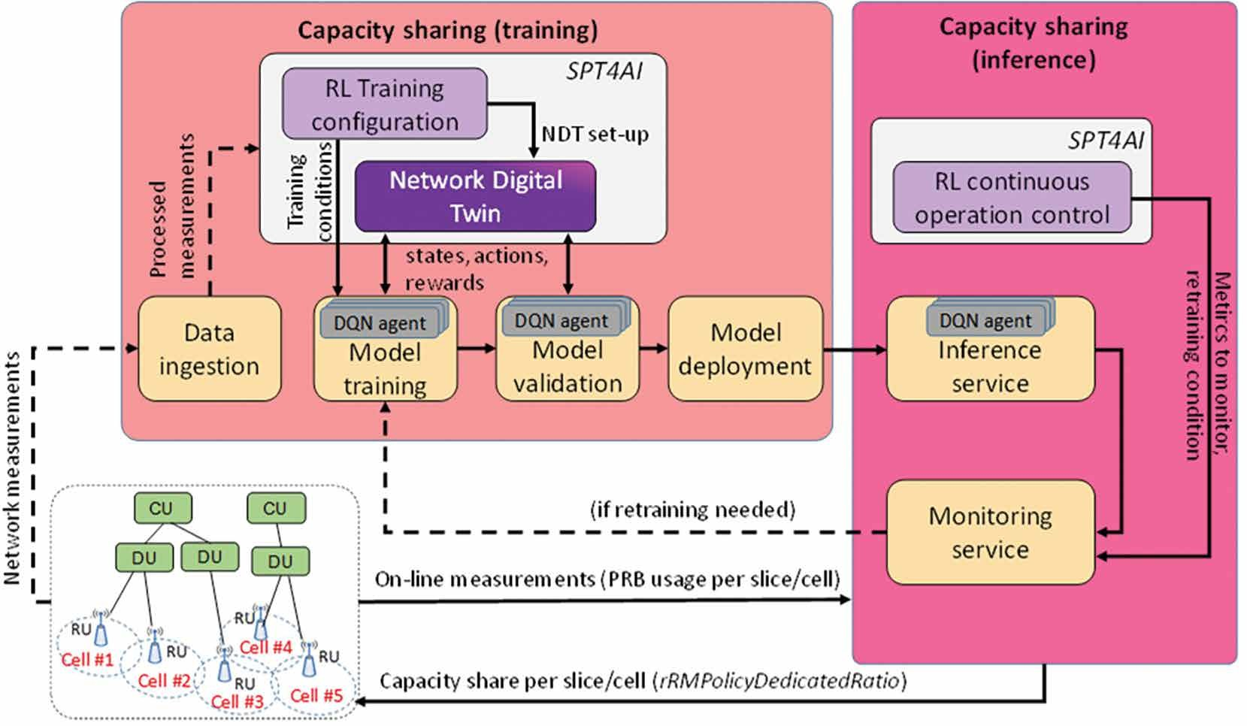
FIGURE 3. AI/ML LCM pipeline of the DQN-MARL capacity sharing.

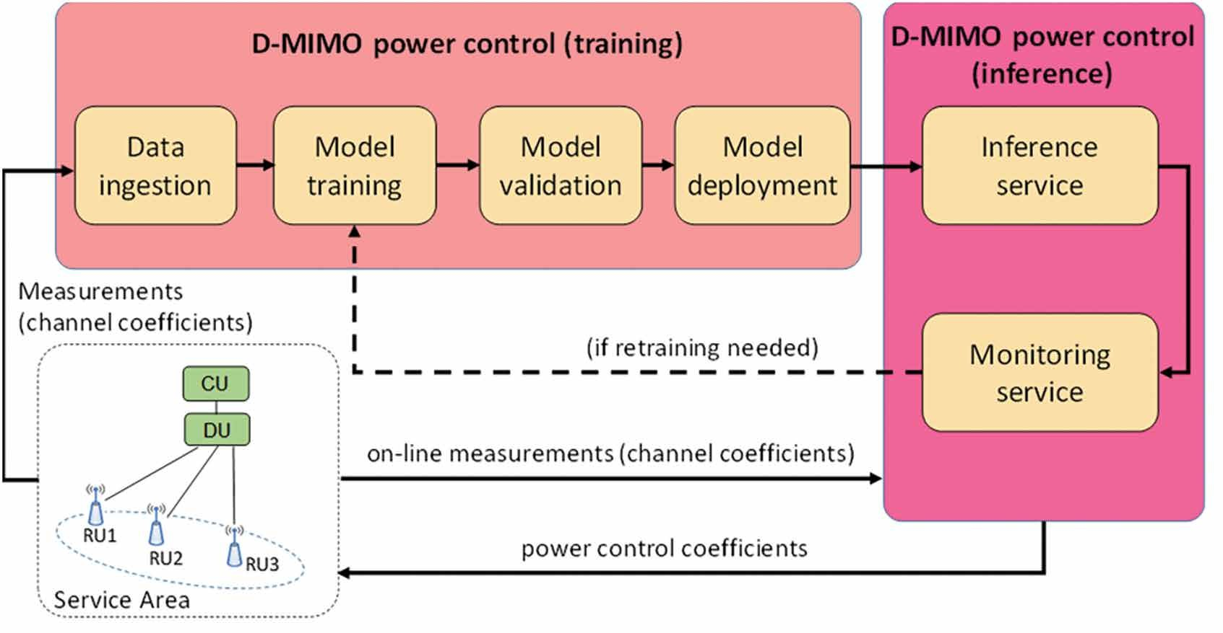
FIGURE 4. AI/ML LCM pipeline of the D-MIMO power control in a service area.

cell in the current time instant. The performance evaluation of this solution can be found in [10].
A key challenge of DQN-MARL is the training to learn the adequate settings of the neural net-work weights that determine the decision-making policy of each agent. Being an RL solution, this training consists in progressively selecting actions and measuring their outcome in terms of a reward used to improve the decision-making policy. Since this includes an inherent trial-and-error action selection process, executing this training directly on the real network could lead to wrong decisions eventually degrading the network performance. Therefore, the training is conducted on a Network Digital Twin (NDT) that provides a virtual repre-sentation of the RAN and allows assessing the effect of the different actions on a safe emulated environment. In this way, each DQN agent gets the state from the NDT, decides the action to be applied and the NDT provides the reward that assesses the resulting performance after applying the allocated capacity shares.
Fig. 3 illustrates the AI/ML LCM processes
particularized to the DQN-MARL solution. The model training and deployment phase, shown in the figure as the capacity sharing (training) block, includes the data ingestion, model training, model validation and model deployment processes. In this phase, the DQN-MARL solution is firstly trained using the NDT and, once a training ter-mination condition is met, the model is validated with the NDT before deploying it in the real RAN. The model inference and monitoring phase, shown in the figure as the capacity sharing (infer-ence) block, includes the inference and monitoring services in which the DQN-MARL solution gets online measurements of the radio resource usage per slice and cell of the real RAN and decides the values of the rRMPolicyDedicatedRatio.
The AI lifecycle pipeline includes SPT4AI func-
tionalities in both training and inference to ensure the trustworthiness of the solution. Specifically, the training block includes the RL training con-figuration function and the NDT. The RL training configuration function determines the conditions
to efficiently train the DQN-MARL model, trad-ing-off aspects such as the training duration, the accuracy and the generalization capability of the learnt policy. This is done by specifying the hyperparameters of the DQN agents, the train-ing termination condition, and the set-up of the NDT so that it produces a diversity of RAN sit-uations that a DQN agent could face in a real network. The NDT set-up, specified for both the training and validation stages, can be based on real network measurements (e.g., load levels, user distributions, propagation conditions, etc.) conve-niently processed at the data ingestion.
In turn, the inference block includes the RL continuous operation control function to monitor the behaviour of the DQN-MARL model during inference to detect degradations (e.g., due to changes in the environment), analyse their root cause and, if needed, decide to perform a retrain-ing. This function controls the monitoring service stage by specifying the performance indicators to monitor and the conditions to decide that a retraining of the solution is needed.
AI-DRIveN POweR cONTROL fOR D-MIMO
The considered D-MIMO power control strategy is an AI regression model whose input is a vec-tor of channel information coefficients for each pair of RU and User Equipment (UE). The channel information coefficients can be estimated e.g., using reference signals. The regression model learns to map these channel coefficients to power allocations. Specifically, the output is a vector of power control coefficients for each pair of RU and UE that determine the fraction of transmit-ted power devoted to each UE in each RU. The regression task consists in the use of a Deep Neu-ral Network (DNN) that produces the required outputs. The solution’s details and its performance evaluation are available in [11].
Since the operating environment of each ser-
vice area is different, the DNN has to be trained and executed separately for each one. Fig. 4 illus-trates the different processes that constitute the AI/ML LCM pipeline of the solution in one service

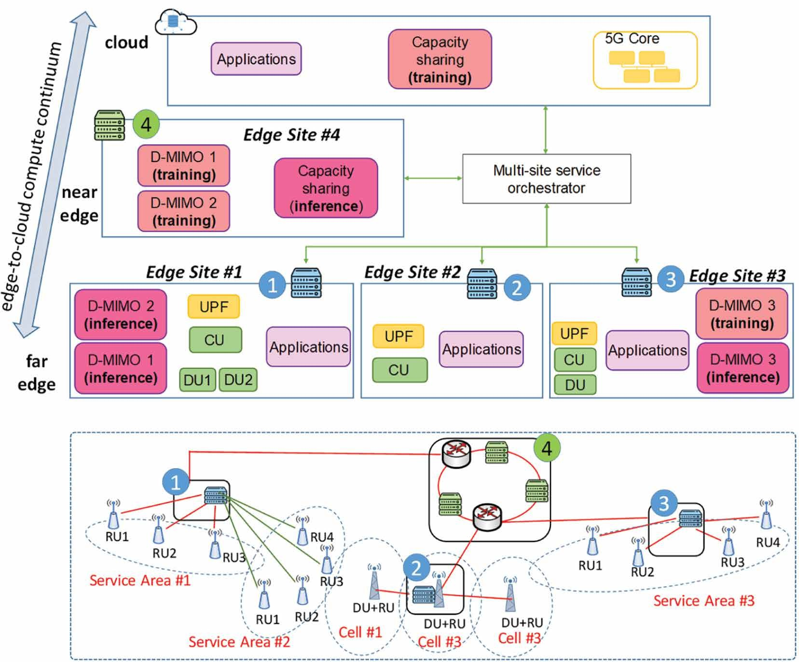
FIGURE 5. Example of deployment of the AI-driven solutions for D-MIMO power control and capacity sharing.

area. They are grouped in the training and infer-ence blocks, which represent, respectively, the model training and deployment phase and the model inference and monitoring phase. The train-ing block uses RU-specific measurements that are pre-processed at the data ingestion to build the training data to be used by the model training. The training consists in an unsupervised learning task that learns the adequate DNN weights for the ser-vice area. Specifically, the training data includes multiple realizations of the channel information coefficients for different UEs and RUs that are rep-resentative enough of the conditions experienced in the service area. Since the training process can be executed offline, these measurements may be collected from the network, stored and provided to the data ingestion process whenever a training is required.
Once trained, the resulting DNN can be val-
idated against a separate dataset by the model validation process to assess its performance and make sure it is ready for deployment on the network. Afterwards, the inference ser-vice uses the trained DNN model and takes as input online measurements of the channel information coefficients of the different UEs and RUs to dynamically decide the power con-trol coefficients to be allocated. This stage also includes the monitoring service to assess the actual performance of the model. Based on this assessment, a retraining can be requested if the conditions used in the training dataset are substantially different from those currently expe-rienced at the service area.

eXAMPLe Of AI MODeL DePLOyMeNTS
Fig. 5 presents a deployment example of the AI pipeline processes for the capacity sharing and the D-MIMO power control solutions across the edge-to-cloud compute continuum of a network. The network is used to provide certain services with stringent latency requirements that involve the execution of computation tasks, e.g. render-ing for extended reality. The figure illustrates that, depending on the environmental characteristics in terms of geometry, served UEs, etc. the operator can decide to deploy D-MIMO in some selected regions, e.g., service areas #1, #2 and #3 in the example, while other ones, e.g. cells #1, #2 and #3, may not require this feature.
The edge-to-cloud compute continuum in Fig. 5 is reflected through the existence of four edge sites, numbered #1 to #4, and a cloud. They host computational, storage and networking resources where different applications or network functions can be executed. Edge sites #1, #2 and #3 corre-spond to the far edge, because they are co-located with the RAN equipment. Specifically, edge site #1 hosts the virtualized functions of the CU and DUs corresponding to service areas #1 and #2. Edge site #2 hosts the virtualized CU of cells #1, #2 and #3 considering that their DUs and RUs are implemented as physical network functions. Edge site #3 hosts the virtualized CU and DU of service area #3. In turn, edge site #4 is located at an aggregation point of multiple cells/service areas in the transport network, so it corresponds to the near edge in the continuum. It is worth not-ing that the edge sites #1, #2 and #3 also host

applications with low latency requirements whose traffic needs to be processed locally at the edge. Thus, they include a local User Plane Function (UPF) to transfer the packets of these applications to the local processor. The different edge sites and the cloud are managed by the multi-site service orchestrator.
The availability of multiple edge sites offers a lot of flexibility for placing the training and inference blocks of the AI-driven solutions in accordance with their needs and the deployed resources. Regarding the DQN-MARL capac-ity sharing solution, it makes decisions affecting multiple cells (or service areas if D-MIMO is also used). Therefore, in Fig. 5 the inference block of this solution is hosted in the edge site #4 that has visibility of the DUs of multiple cells/service areas where it can configure the selected capacity share values per slice. In the VERGE architecture this functionality is associated with the OMC layer of the Edge4AI pillar, and more specifically on a multi-site RAN intelligent controller that makes decisions affecting multiple cell sites. The train-ing block is an offline procedure that typically involves high computational and memory require-ments to support the NDT functionality and the large number of training steps needed to learn a sufficiently robust policy. Therefore, in Fig. 5 the training block is hosted at the cloud, which typi-cally has more powerful computation capabilities than the edge sites.
Concerning the D-MIMO power control
solution, given that it needs to dynamically react to the variations of the fading and the number of scheduled UEs at each time slot, the infer-ence should run at the computational resources of the far edge co-located with the RAN equip-ment of each service area. Thus, in Fig. 5, the edge site #1 includes the D-MIMO power con-trol inference of service area #1, composed of three RUs handled by DU1, and service area #2, composed of four RUs handled by DU2. Indeed, most likely the inference processes can be part of DU1 and DU2, because this will pro-vide faster reactivity. Similarly, the inference of service area #3 is executed at the edge site #3 together with DU3 that handles the four RUs of this service area.
Regarding the training block of the D-MIMO
power control, it involves the processing of training data composed of multiple service area-specific measurements, thus having larger computational requirements than the inference. However, the training process does not have tight delay requirements, as it can be executed offline. Thus, it provides more flexibility to be hosted at different locations of the continuum. Therefore, two possibilities are shown in Fig. 5. The first one is the training of service area #1 and #2, which is executed at the edge site #4 (i.e., the near edge) co-located with an aggregation point. In this way, the training process can benefit from the larger computational capabilities available at this edge site. Moreover, this avoids that the service area-specific measurements needed for the train-ing, which can represent large data volumes, have to be transferred deeper in the network (e.g., if the training was done at the cloud). This enables a more efficient use of transport resources only at the expense of some additional data storage at
the edge site. The second possibility shown in Fig. 5 corresponds to service area #3, in which the training stage is executed locally at the same edge site #3 that hosts the inference. This could repre-sent a situation in which the edge site has enough computational resources to support all its pro-cesses. It could also be the case of a remote site so that keeping the training data locally reduces the load in the transport links and also avoids security concerns stemming from data transfers.
It is worth mentioning that the deployment example shown in Fig. 5 can be flexibly mod-ified by the multi-site service orchestrator. The placement of the D-MIMO training block, the capacity sharing inference/training blocks and the applications across the edge-to-cloud com-pute continuum can be decided based on criteria targeting performance improvements in e.g., resource utilization efficiency, traffic load or energy consumption. Human-based, rule-based, and/or AI-based orchestration actions can be exe-cuted to enforce these decisions.
DePLOyMeNT Of AI4eDge SOLUTIONS IN O-RAN
This section analyses different aspects of the AI-driven capacity sharing and D-MIMO power control deployments from the perspective of their relationship with current standardisation activities at O-RAN alliance.
The O-RAN alliance architecture includes spe-cific functional elements for RAN control, such as the near-real time RAN Intelligent Controller (RIC) and the non-real time RIC that support AI/ ML models for the RAN [12]. These can host soft-ware modules of inference/training stages of AI/ ML models provided by third parties, e.g., in the form of the xApps hosted in the near-real time RIC, which have control loops between 10ms and 1s, or the rApps hosted in the non-real time RIC, with control loops above 1s. Moreover, ongoing studies in the O-RAN next Generation Research Group - Research Stream 02 focusing on archi-tecture towards 6G O-RAN [13] also consider the distributed applications (dApps) [14], which could form real-time control loops reaching even below 1 ms time scales. In general, the provision of AI/ML models by third parties as xApps, rApps or eventually dApps requires properly defined interfaces with the managed nodes to collect the necessary measurements and to provide the configuration control commands. In this respect, the O-RAN architecture includes the E2 interface between near-real time RIC and DU and the O1 interface between the CU/DU and the Service Management and Orchestration where the non-real time RIC resides.
The operation time scale of the DQN-MARL
solution is in the order of minutes, so the infer-ence could be materialized as a non-real time RIC rApp. The required online measurements with the radio resource usage per slice/cell can be provided by the DU through the O1 interface as part of the Performance Measurements defined in 3GPP TS 28.552. Similarly, the O1 interface is also used to configure the resulting rRMPoli-cyDedicatedRatio at the DU.
For the D-MIMO power control, the decisions made by the inference stage modify the power control coefficients based on the channel informa-tion coefficients. The time scale of these decisions

is in the order of 1 ms as they should follow the scheduling algorithm that modifies the UEs that transmit in each time slot. Thus, if the inference stage of the algorithm had to be implemented in the context of the O-RAN architecture, its timing constraints would only fit with the time scale of a dApp. In such a case, the dApp should have access to Layer 1 data, e.g., to collect informa-tion from sounding signals that facilitates the determination of the channel information coeffi-cients, and it should be tightly coupled with the scheduling algorithm. However, the interfaces currently defined by O-RAN are not able to pro-vide such information. In this regard, third party dApp implementations would require the defini-tion and standardisation of new service models and the co-location of RAN and AI/ML functions on a shared hardware platform [15]. Given these limitations, the most feasible implementation of the inference would be a proprietary solution in which the AI/ML model is directly integrated in the DU and provided by the DU vendor.
In turn, the training stage, which does not
have tight delay constraints and can be executed offline, would accept an implementation e.g., as a non-real time RIC rApp. If so, a key aspect would be the provision of the channel informa-tion coefficients to be used as training data. These coefficients should be collected by the DU and provided to the rApp. Given that current O1 interface does not include this type of data, a pro-prietary interface should be used in this case.

cONcLUSION
This paper has presented a pipeline for the life-cycle management of trustworthy AI/ML models in edge-enabled B5G networks. The deployment of this pipeline for two AI-driven RAN control solutions in an edge-to-cloud compute contin-uum has been discussed. This continuum provides a high flexibility for deploying AI/ML functions, user applications or network functions at different sites. Specifically, the placement of the training and inference stages for a reinforcement learn-ing-based capacity sharing solution and for an unsupervised learning-based D-MIMO power control has been analysed depending on the geo-graphical scope, the access to the required data or the required reactivity of each solution. Moreover, the deployment of these solutions in O-RAN has been studied, concluding that the capacity sharing approach fits well into the current O-RAN non-real time RIC framework. In contrast, a proprietary
implementation at the DU appears to be the best option for the D-MIMO power control strategy, due to its operation time scale in milliseconds and the capabilities of current O-RAN interfaces.

AckNOwLeDgMeNT
Views and opinions expressed are, those of the authors only and do not necessarily reflect those of the European Union. Neither the European Union nor the granting authority can be held responsible for them.

RefeReNceS
- W. Saad, M. Bennis, and M. Chen, “A vision of 6G wireless systems: Applications, trends, technologies, and open research problems,” IEEE Netw., vol. 34, no. 3, pp. 134–142, May 2020.
- Ö. T. Demir, E. Björnson, and L. Sanguinetti, “Foundations of user-centric cell-free massive MIMO,” Found. Trends Signal Process., vol. 14, nos. 3–4, pp. 162–472, 2021.
- F. Alriksson et al., “Future network requirements for extend-ed reality applications,” Ericsson Technol. Rev., vol. 2023, no. 4, pp. 2–12, Apr. 2023.
- High Priority Edge Computing Standardisation Gaps and Rele-vant SDOs, AIOTI, Brussels, Belgium, Apr. 2022.
- E. Kartsakli et al., “Advanced edge computing architecture for AI-driven automation and slicing in beyond 5G,” in Proc. IEEE/ACM 17th Int. Conf. Utility Cloud Comput. (UCC), Shar-jah, United Arab Emirates, Dec. 2024, pp. 321–326.
- J. Pérez-Romero et al., “On the deployment of an AI-driv-en power control mechanism for D-MIMO in beyond 5G scenarios,” in Proc. IEEE Conf. Standards Commun. Netw. (CSCN), Nov. 2024, pp. 377–382.
- A. Yousefpour et al., “All one needs to know about fog com-puting and related edge computing paradigms: A complete survey,” J. Syst. Archit., vol. 98, pp. 289–330, Sep. 2019.
- E. Kartsakli et al. (Apr. 2025). Final Report on VERGE Edge4AI Design. Deliverable D2.2 of VERGE Project. Accessed: Oct. 27, 2025. [Online]. Available: https://www.verge-project. eu/dissemination/deliverables
- M. Mueck and C. Gaie, “Introduction to European data relat-ed regulation,” in Chapter of European Digital Regulations. Cham, Switzerland: Springer, 2025.
- I. Vilà et al., “A multi-agent reinforcement learning approach for capacity sharing in multi-tenant scenarios,” IEEE Trans. Veh. Technol., vol. 70, no. 9, pp. 9450–9465, Sep. 2021.
- Ö. F. Tuna and F. E. Kadan, “A flexible, efficient and robust method for AI-driven power control in D-MIMO,” in Proc. IEEE Int. Medit. Conf. Commun. Netw. (MeditCom), Sep. 2023, pp. 56–61.
- O -RAN Architecture Description, document O-RAN.WG1. OAD-R003-v12.00, O-RAN Alliance, Jun. 2024.
- S. D’Oro et al., “dApps for real-time ran control: Use cases and requirements,” O-RAN Next Gener. Res. Group (nGRG), Alfter, Germany, Tech. Rep. RR-2024-10, Oct. 2024.
- S. D’Oro et al., “DApps: Distributed applications for real-time inference and control in O-RAN,” IEEE Commun. Mag., vol. 60, no. 11, pp. 52–58, Nov. 2022.
- (Feb. 26, 2024). Advancements in RAN Through AI-AI for RAN. SoftBank. Accessed: Mar. 17, 2025. [Online]. Available: https://www.softbank.jp/en/corp/technology/ research/story-event/040/

